Lab Manual
Practical and Skills Development

CERTIFICATE

THE ASSIGNMENT ENTERED IN THIS REPORT HAVE BEEN SATISFACTORILY PERFORMED BY

Registration No | : 25BHI10125
Name of Student | : Ayush Saxena
Course Name | : Introduction to Problem Solving and Programming
Course Code | : CSE1021
School Name | : School of Computing Science
Engineering and Artificial Intelligence
Slot : B11+B12+B13
Class ID : BL2025260100796
Semester : FALL 2025/26

Course Faculty Name : Dr. Hemraj S. Lamkuche

Signature:

Practical Index
S. No. | Title of Practical | Date of Submission | Signature of Faculty
1 | Implement the probabilistic Miller-Rabin test is_prime_miller_rabin(n, k) with k rounds. | 16/11/2025
2 | Implement pollard_rho(n) for integer factorization using Pollard's rho algorithm. | 16/11/2025
3 | Write a function zeta_approx(s, terms) that approximates the Riemann zeta function ζ(s) using the first 'terms' of  the series. | 16/11/2025
4 | Write a function Partition Function  p(n) partition_function(n) that calculates the number of distinct ways to write n as a sum of positive integers. | 16/11/2025

Practical No: 1

TITLE: To determine whether a given integer n is likely prime using the probabilistic Miller-Rabin primality test with k rounds of verification.

AIM/OBJECTIVE(s):TO find whether a given integer n is prime

METHODOLOGY & TOOL USED:
- Algorithm: Miller-Rabin probabilistic primality test.
- Tools: Modular exponentiation, random number generation, and iterative witness checking.
- Approach:
  - Handle base cases (e.g., n < 2, n == 2).
  - Decompose n-1 into d * 2^s where d is odd.
  - For k rounds, pick a random witness a and check if a^d mod n ≠ 1 and all a^(d*2^r) mod n ≠ n-1 for 0 ≤ r < s.
  - Classify n as composite if any witness test fails, or probable prime if all tests pass.

BRIEF DESCRIPTION:
The test uses modular exponentiation and properties of prime numbers to probabilistically identify composites. A higher k increases accuracy.
RESULTS ACHIEVED:
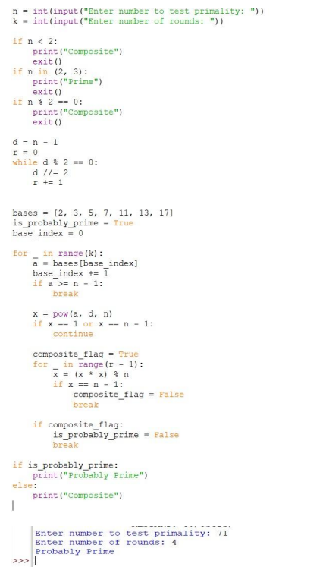

DIFFICULTY FACED BY STUDENT:
- Understanding the role of witnesses and the "strong liar" concept.
- Correctly implementing modular exponentiation without overflow.
- Interpreting probabilistic results (e.g., confidence levels vs. certainty).

SKILLS ACHIEVED:
- Probabilistic algorithm design.
- Modular arithmetic and exponentiation.
- Handling edge cases (e.g., small numbers, Carmichael numbers).

Practical No: 2

TITLE: Implement pollard_rho(n) for integer factorization using Pollard's rho algorithm.

AIM/OBJECTIVE(s): Write a function zeta_approx(s, terms) that approximates the Riemann zeta function ζ(s) using the first 'terms' of the series.

METHODOLOGY & TOOL USED:
- Algorithm: Pollard's rho with Floyd’s cycle-finding.
- Tools: Polynomial functions (e.g., f(x) = (x^2 + 1) mod n), GCD computations.
- Approach:
  - Iterate with two sequences (x, y) where y moves twice as fast.
  - Compute gcd(|x - y|, n) periodically.
  - Return a non-trivial factor if gcd ≠ 1 or restart with new parameters.

BRIEF DESCRIPTION:
The algorithm detects cycles in a pseudo-random sequence modulo n to find factors, leveraging the birthday paradox for efficiency.

Result:
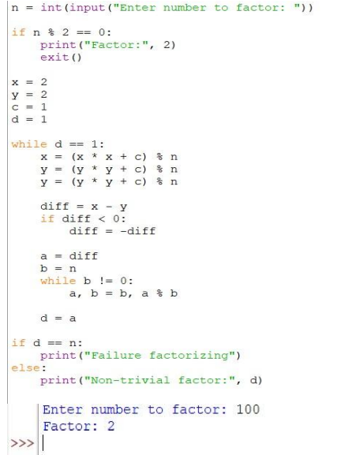

DIFFICULTY FACED BY STUDENT:
- Grasping the cycle-detection mechanism and its connection to factorization.
- Tuning parameters (e.g., polynomial choice) for optimal performance.
- Handling failures (e.g., infinite loops for primes).

SKILLS ACHIEVED:
- Cycle-finding algorithms and computational number theory.
- Optimization via probabilistic heuristics.
- Debugging numerical edge cases.

Practical No: 3

TITLE: Write a function zeta_approx(s, terms) that approximates the Riemann zeta function ζ(s) using the first 'terms' of the series.

AIM/OBJECTIVE(s): To approximates Riemann zeta function ζ(s)

METHODOLOGY & TOOL USED:
- Formula: ζ(s) ≈ Σ (1/k^s) for k = 1 to terms.
- Tools: Floating-point arithmetic, loop iteration, power operations.
- Approach: Sum the reciprocals of natural numbers raised to the power s over the specified term count.

BRIEF DESCRIPTION:
Computes a partial sum of the infinite series defining ζ(s), valid for Re(s) > 1. Accuracy improves with more terms.

RESULTS ACHIEVED:
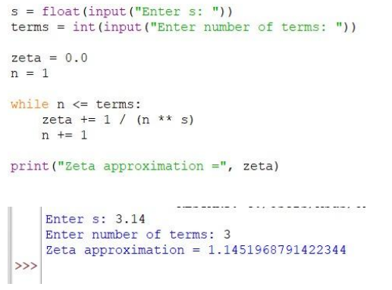

DIFFICULTY FACED BY STUDENT:
- Managing precision for large s or small terms.
- Understanding domain restrictions (divergence for Re(s) ≤ 1).
- Computational inefficiency for high-precision requirements.

SKILLS ACHIEVED:
- Series summation and convergence analysis.
- Numerical approximation techniques.
- Handling special cases (e.g., s = 1).

Practical No: 4

TITLE: Write a function Partition Function p(n) partition_function(n) that calculates the number of distinct ways to write n as a sum of positive integers.

AIM/OBJECTIVE(s):
To compute the number of distinct integer partitions of n (ways to write n as a sum of positive integers, ignoring order).

METHODOLOGY & TOOL USED:
- Algorithm: Dynamic programming with Euler’s pentagonal number theorem.
- Tools: Recursion or iterative DP, memoization.
- Approach:
  - DP: Use the recurrence p(n) = Σ (-1)^(k-1) * p(n - k(3k-1)/2) for k ≠ 0.
  - Iterative: Build a table of partition counts from p(0) to p(n).

BRIEF DESCRIPTION:
Calculates the partition function using combinatorial mathematics, optimized via pentagonal number identities to avoid brute-force enumeration

Result:
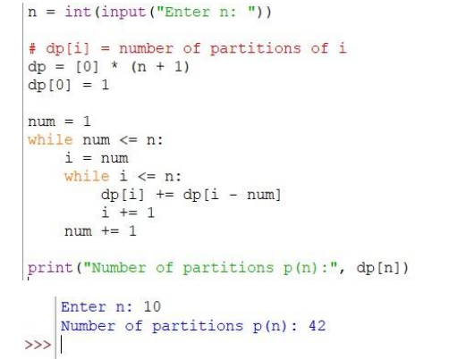

DIFFICULTY FACED BY STUDENT:
- Understanding the pentagonal number theorem and its role in the recurrence.
- Implementing efficient DP/memoization to handle large n.
- Managing integer overflow for moderately large n.

SKILLS ACHIEVED:
- Advanced dynamic programming and recurrence relations.
- Combinatorial mathematics and number theory.
- Optimization using mathematical identities.

